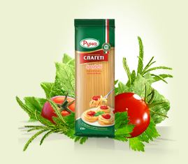
Macaroni «Spageti»
Ingredients: flour out of hard pasta wheat (durum), drinking water.
Shelf life: to +30˚С – 2 years
Netto weight: 450 g

Macaroni have higher protein content than either corn or rice containing starch and fibers. Macaroni is a source of group B vitamins that results in high value for good nutrition.
‘Runa’ TM macaroni features are:
- Cream- or yellow-coloured (single-colour );
- Macaroni surface is smooth but could appear some roughness. Bends and distortions are allowable in several types of macaroni only for improvement of the product marketability;
- Macaroni do not re-shape and do not agglutinate while cooking.
‘Runa’ TM macaroni foods are produced on the modern equipment according to a unique recipe which is based on using the best flour out of hard pasta wheat (durum).
‘Runa’ TM pasta could not be tenderized; they do not stick together and do not need additional washing. Dishes cooked with ‘Runa’ macaroni as main ingredient have nice fragrance and exquisite taste.
Cooking Instructions: Take not less than 1 l of water, boil the water and add soil (1/3 tsp. per 100 g of macaroni). Put macaroni in boiling water on low heat for 7-10 minutes and stir it a little periodically during the recommended time. Pour the water out of the prepared macaroni. Washing of the prepared macaroni can be done but is not obligatory.

