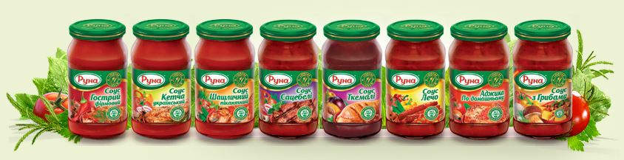
Sauce is a complicated and original composition of tomatoes, scented spicery and spices. You should have specific skills to cook the sauce. And every experienced cook will surely say that the main ingredient for good cooking is the sauce.
‘Runa’ TM proposes a wide range of sauces up to any possible taste which could easily enrich every dish by adding delicate, piquant and tender taste. All sauces of the ‘Runa’ have its separate taste and smell, make Your dishes full, and rise dish energy value.
Improve Your cooking skills with our sauces!

